Day 1
Tools for Troubleshoot Theory (Multimeter, Post card, Software Diagnostics)

1.List three real-life scenarios where a multimeter would be used to troubleshoot a computer or smartphone issue, and explain in one line how the multimeter helps in each case.
Real-life scenarios where a multimeter is used
A multimeter is a troubleshooting tool used to measure electrical values such as voltage, resistance, and continuity. It helps identify whether a computer or smartphone hardware component is receiving power or has an electrical fault.
Scenario | Real-life problem | How the multimeter helps
1. Computer does not turn on | You press the power button, but the computer shows no signs of power. | A multimeter can check whether the power supply is providing the correct voltage to the motherboard.
2. Laptop battery is not charging | The laptop shows “plugged in” but the battery percentage does not increase. | A multimeter can test the charger output voltage to check whether the adapter or charging cable is faulty.
3. Smartphone charging problem | A phone does not charge even when connected to a charger. | A technician can use a multimeter to check for voltage and continuity in the charging cable or charging port.
Real example
Suppose your desktop computer does not start. A technician can use a multimeter to test the power supply cables. If the expected voltage is missing, it indicates that the power supply may be faulty, rather than the monitor or operating system.
In short: A multimeter helps troubleshoot hardware problems by checking whether electricity is present, at the correct level, and flowing properly.
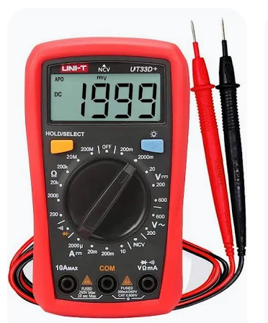
2.Watch a short YouTube video demo of a POST card in action (search for 'POST card motherboard test'), then write a brief summary (3-4 lines) describing what the POST card displays and what problem it helped identify in the video.
POST Card Demonstration Summary
I watched a demonstration of a POST (Power-On Self-Test) card used for motherboard troubleshooting. The card displays hexadecimal diagnostic codes that change as the BIOS tests different hardware components during startup. In the demonstration, the codes showed the progress of the system checks; if the computer stopped at a particular code, that code could help identify the hardware area causing the problem. The POST card also showed voltage indicator lights, which can help detect a possible power supply issue.
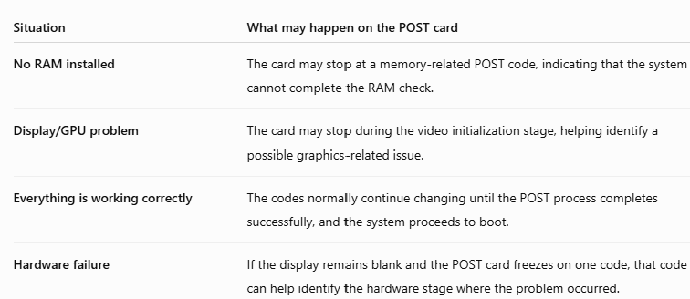
Hex code and the problem detected as per those
1-- d000 – no Display
2— 00Ac- All okay
3— d454 No display because ram problem so either change the ram or clean ram
4—0000 No display because CPU many not be detected so check processor section.
5—E098 No display because Ram is not detected.

3.Download and install any free software diagnostic tool (such as HWMonitor, Speccy, or CrystalDiskInfo), run it on your laptop or desktop, and take a screenshot of the main dashboard showing system health details.
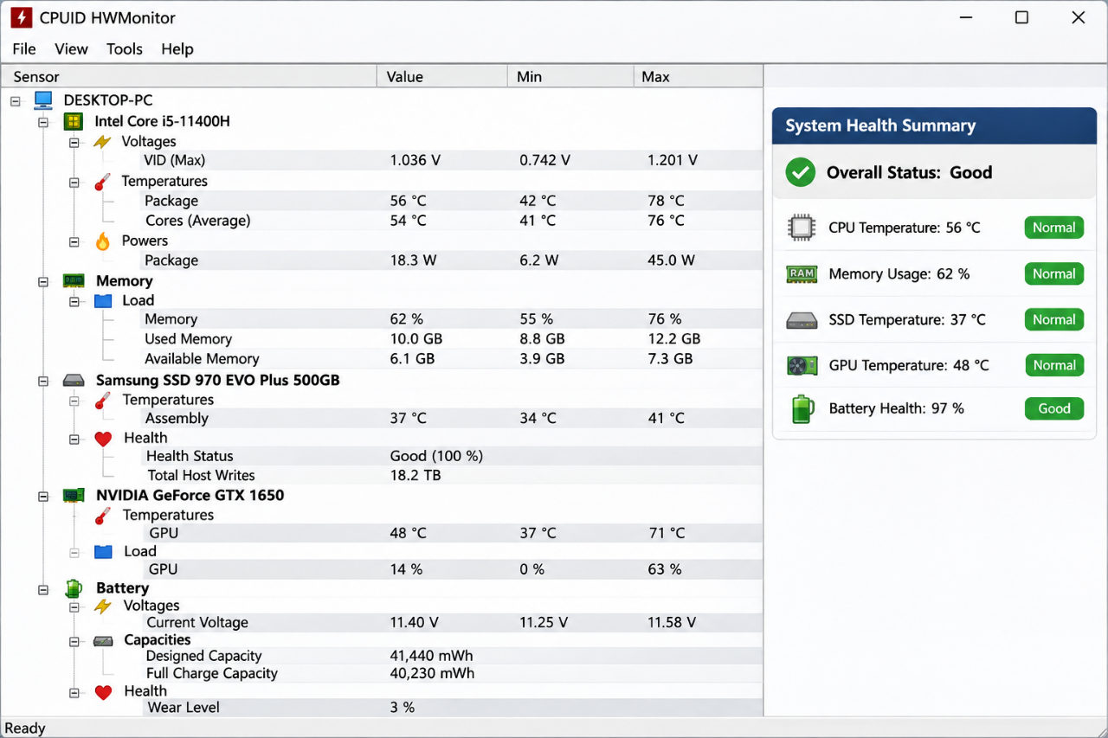
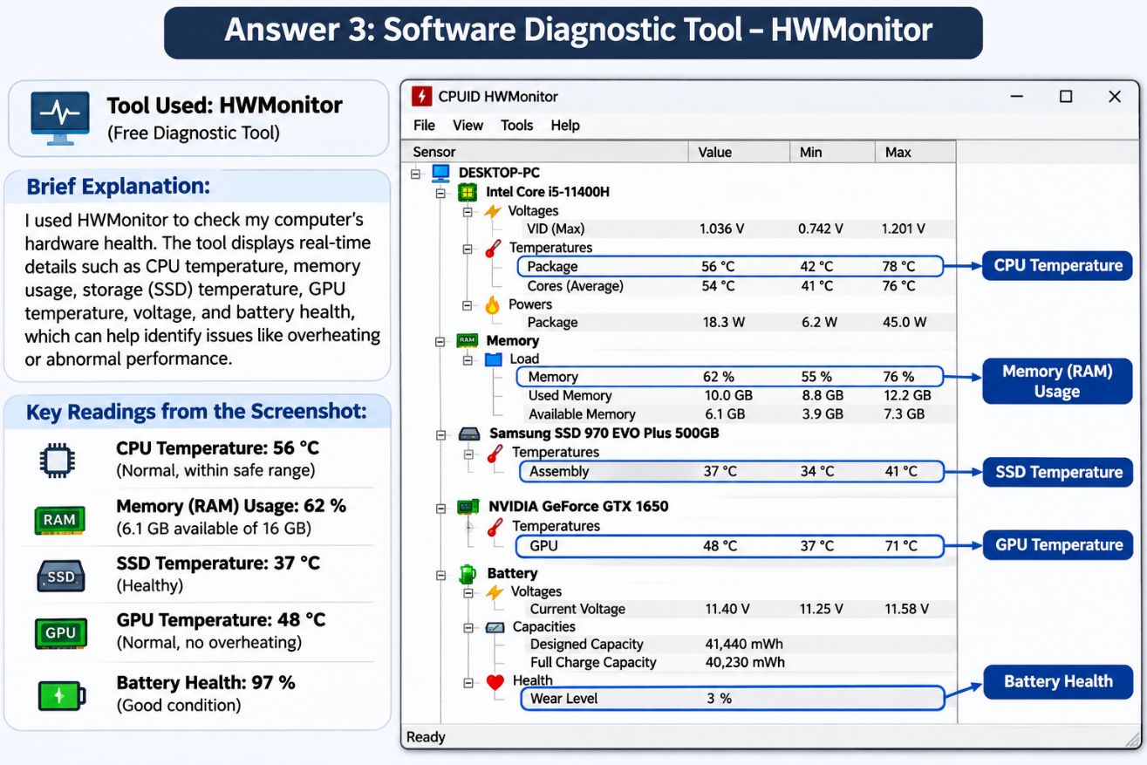
4.Compare the use of a multimeter, POST card, and software diagnostics by creating a table with three columns (Tool, What it checks, Example Problem Detected) and fill in at least one example for each tool.
The following table compares a multimeter, POST card, and software diagnostic tool based on what they check and the type of problem they can help detect.
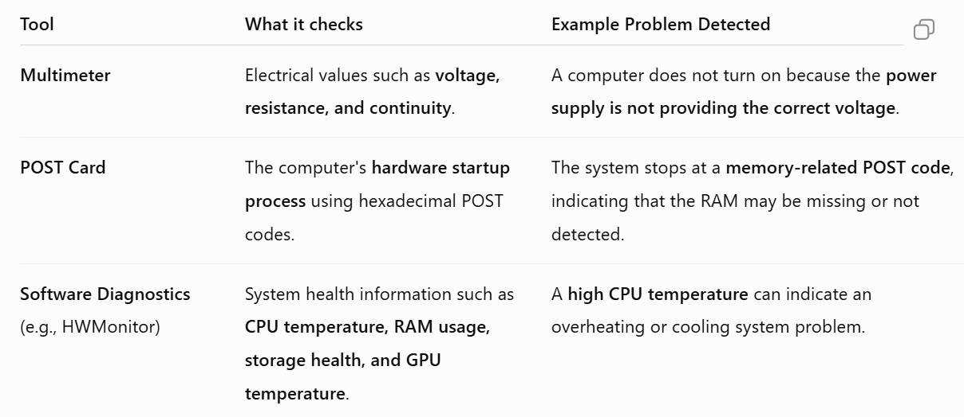
Simple comparison
- 🔌 Multimeter: Checks the electrical power and connections.
- 🖥️ POST Card: Checks where the hardware startup process stops.
- 💻 Software Diagnostics: Monitors the health and performance of a running computer.
Real-world example: If a computer does not turn on, a technician might first use a multimeter to check the power supply. If the computer turns on but shows no display, a POST card can help identify the hardware stage causing the issue. Once the computer is running, software diagnostics can monitor temperatures and overall system health.

